**EE 463 STATIC POWER CONSERVATION-PROJECT 1**

**REPORT**

**Hamza SOLAK-2263762**

**Muhammed BARIŞ- 2030278**

**Question 1)**

1. Voltage output of single-phase half bridge rectifier can be observed in figure 1,2,3.

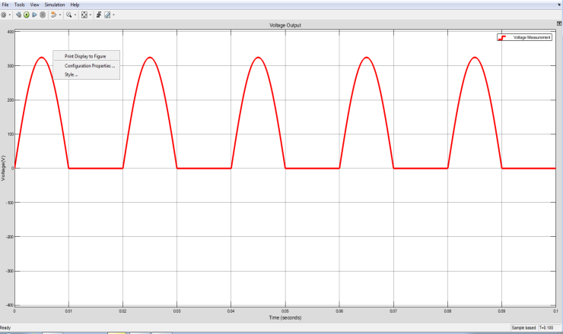

*Figure 1: Output voltage of half bridge rectifier in 1ns*

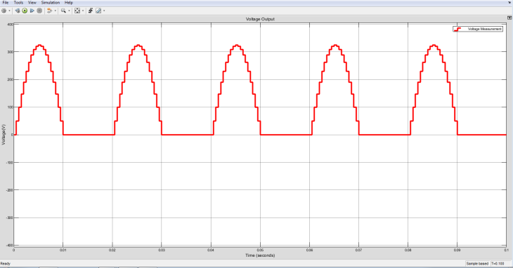

*Figure 2: Output voltage of half bridge rectifier in 0.5ms*

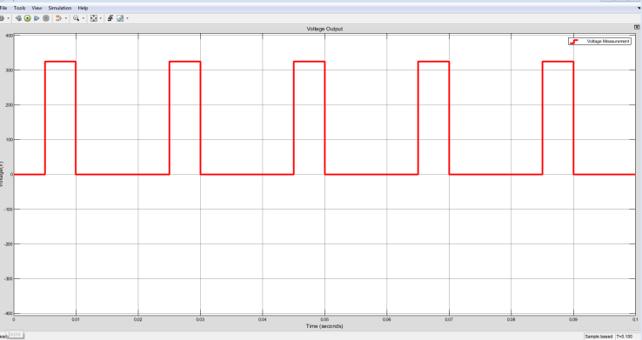

*Figure 3: Output voltage of half bridge rectifier in 5ms*

1. Obvious observation is that higher sampling frequency gives smoother curves. When sampling time is 1ns, it does not even look like a sampled signal. It looks like a pure sinusoid. When sampling period rises, smoothness starts disappearing. Especially with T=5ms, it is observed that the signal s a duty cycle and far from the real signal. With such a high sampling time it won’t be possible to even recover the original signal.

There is a tradeoff between performance and operation time. Higher frequencies obviously achieve much realistic results but take longer to do the simulation. On the other hand, lower frequencies lack in performance but it takes less time to do the operation.

1. Average voltage formula is given below

*Vav=*

*=(2Vsrms*)/(2*pi)= 0,45Vsrms*

*=103.5V*

For calculation of THD, harmonics of wave must be calculated. In first step Fourier transformation must be made. Current wave equations are given below;

*I(t)= 0 when –pi/w<t<0*

*I(t)= Imax*sin(wt) when 0<t<pi/w*

*a0==*

*an=0 when n=1,3,5,7…*

*an= for n=2,4,6,8…*

*b1=1/2*

*bn=0 for all n values*

*THD= $\frac{\sqrt{{0.21}^{2}+{0.042}^{2}+{0.018}^{2}…….}}{1/2}≈0.43$*

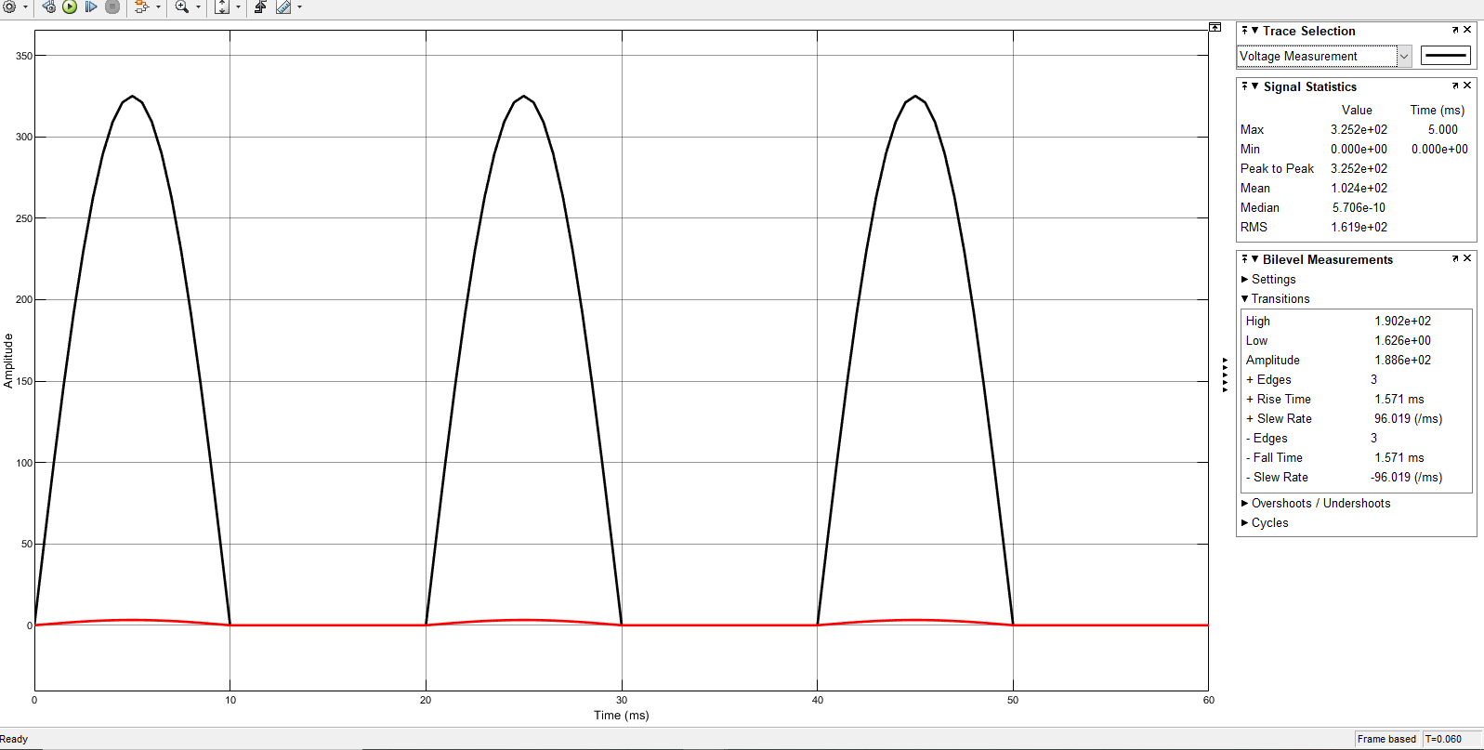

*Figure 4: Mean of output voltage*

Diode in MATLAB is not an ideal diode. It has some mom-idealities. Hence, there is a slight fluctuation which can be observed in “Fiugre4” but it is not a significant one. We can say that it is close enough to ideal.

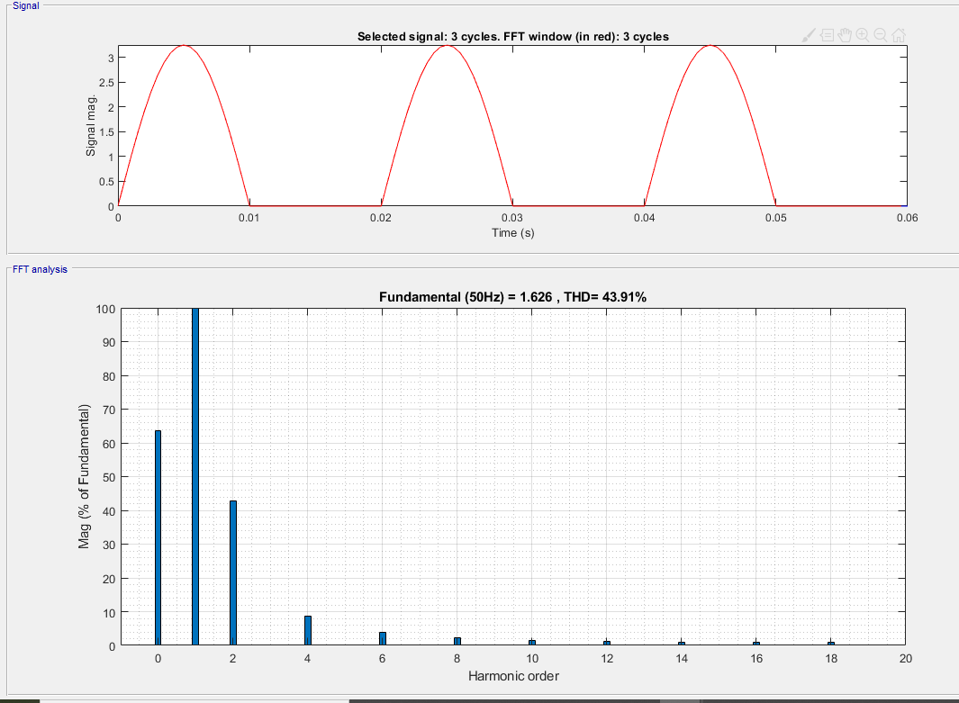

*Figure 5: THD measurement of input current*

As harmonics increase, their magnitude decreases and harmonics goes to infinity with decaying. Since we cannot sum all harmonic waves as it goes to infinity, we can find THD values only smaller than measurement values. Unlike us, a computer can measure THD for a long range of values. Hence, THD value computed by a computer is larger than THD value found by calculation although there is not a big difference in-between. It can be seen in “Figure 5” that harmonics’ magnitude decreases with increasing frequency.

**Question 2)**

1. It represents grid line. Since cables are not superconductive, some of the energy is lost on its way to load. This loss is represented by a resistor. Also the current carried create magnetic field. This is represented by an inductance.
2. In simulation we tried a big capacitance for decreasing output voltage peak-to-peak ripple. Firstly, we tried 1mF I take output which is shown in “Figure 5”.

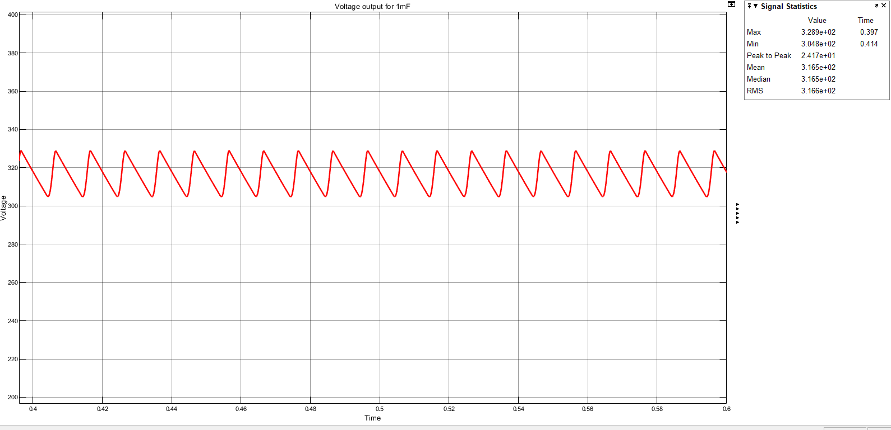

*Figure 6: Voltage output for 1mF*

Its peak to peak ripple is %7. Hence, the capacitance value must be increased. 1.5mF is the suitable for %5 peak to peak ripple value.

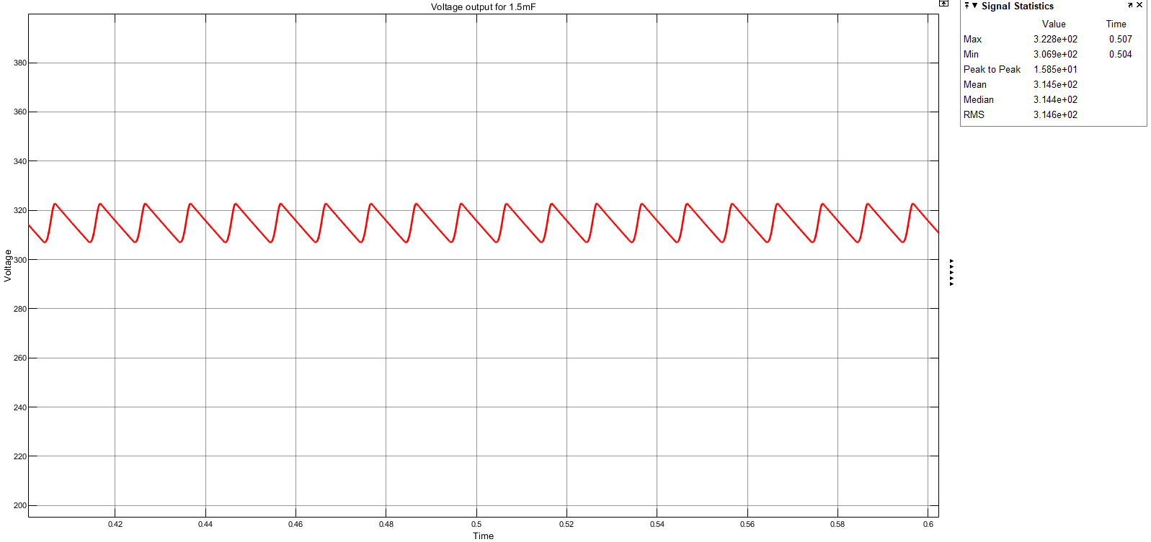

*Figure 7: Voltage output for 1.5mF*

As we see in figure 6 peak to peak voltage is 16V as we calculate peak to peak ripple value is $\frac{16}{322}*100=\%4.96$

İt is near the %5 value.



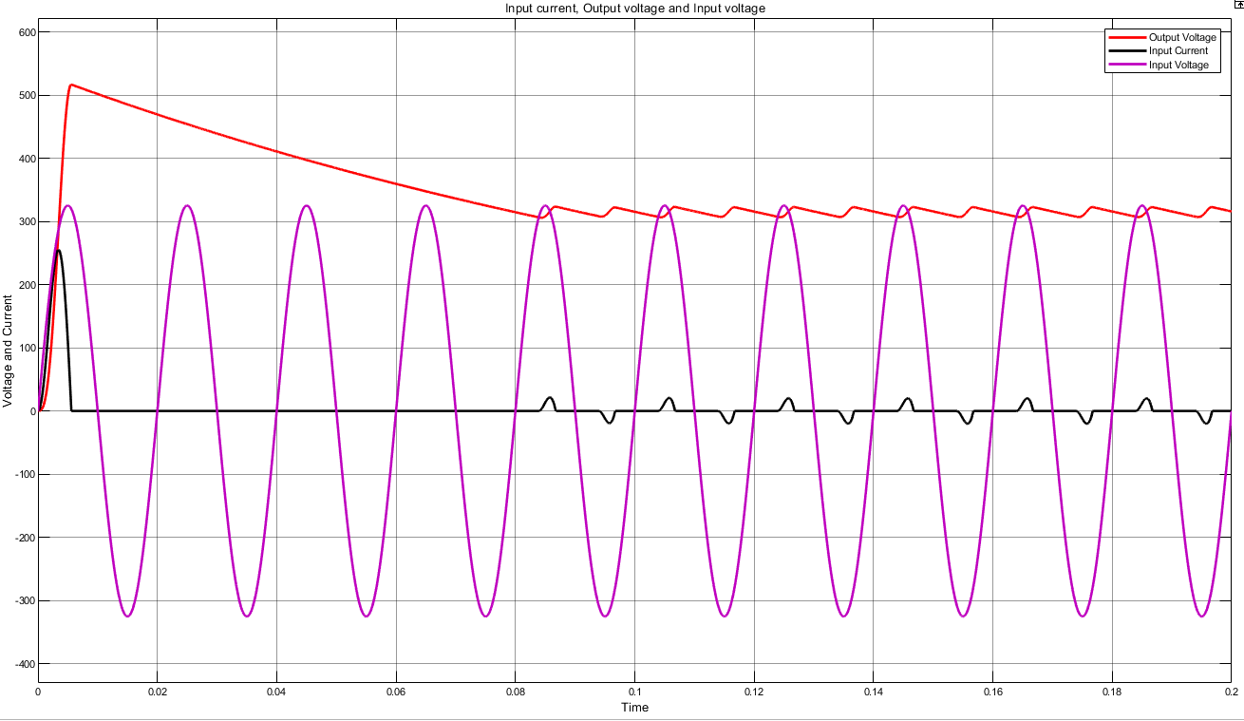

*Figure 8: Input current input voltage and output current for full-wave rectifier*



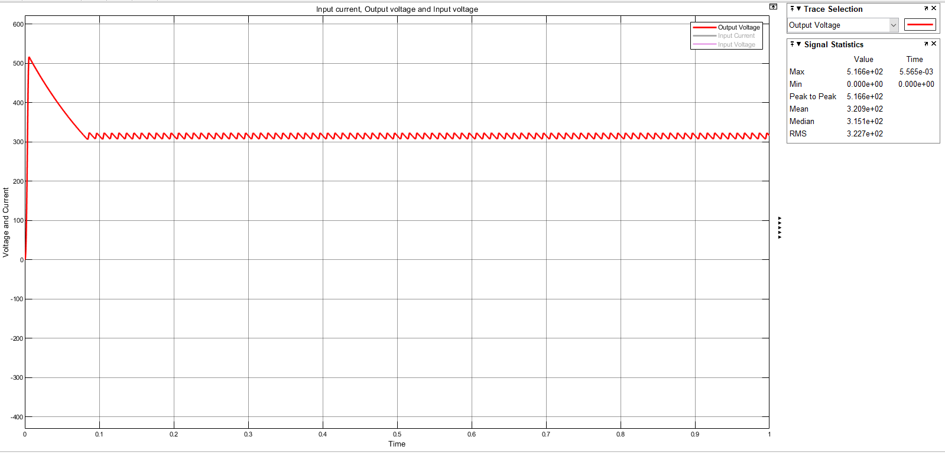

*Figure 9: Average voltage of Output*

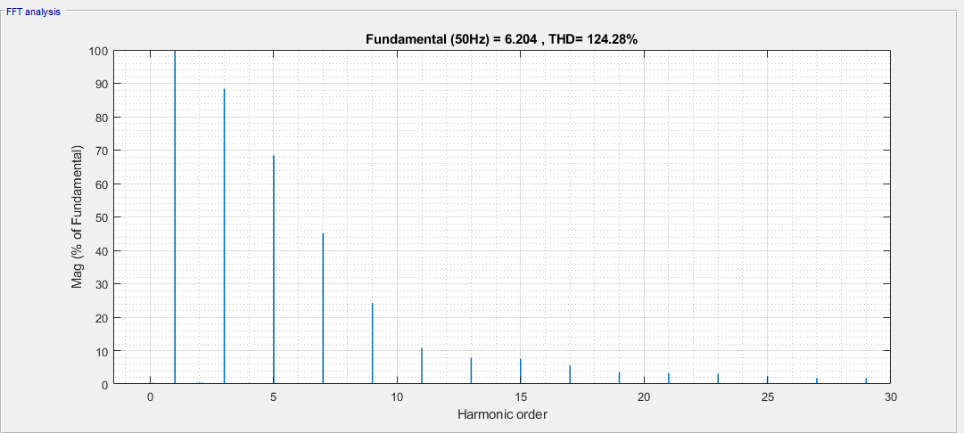

*Figure 10: THD of input current*



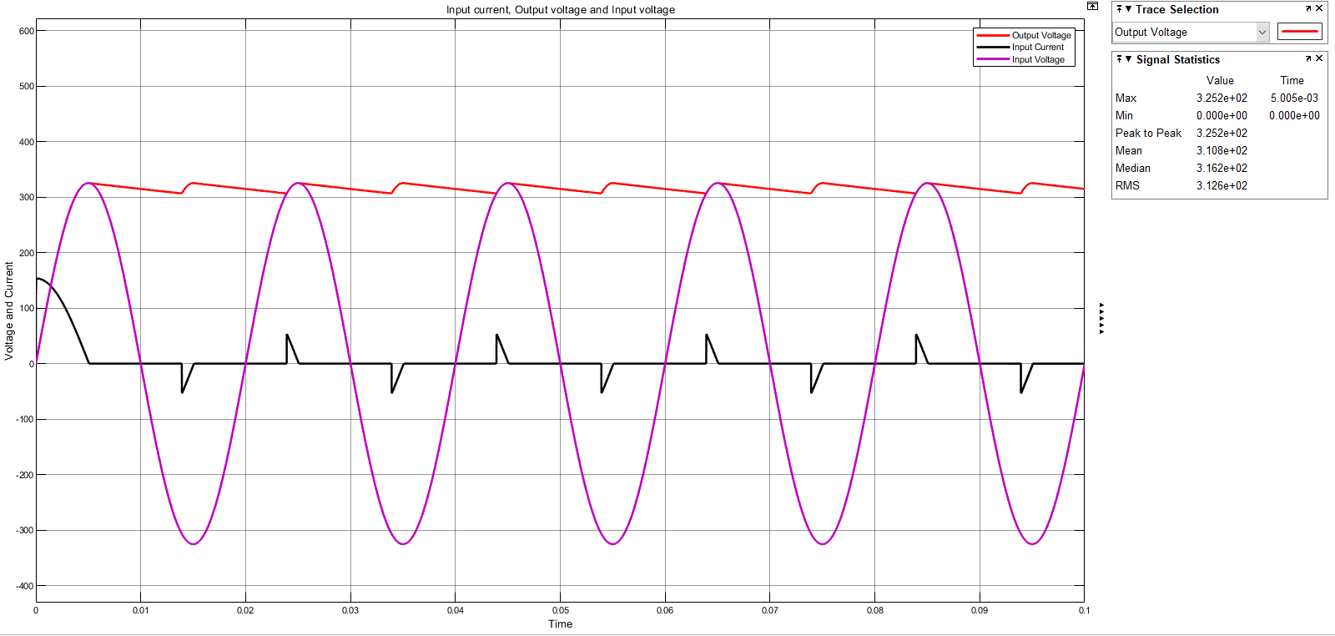

*Figure 11: Input current input voltage and output current for full-wave rectifier without Rs and Ls*

1. Maximum input current is 53.5 A so we must choose 60A diode and maximum reverse voltage is -325.5V. Hence, our diode must stand this value. That’s why we choose a 400V 60A diode. It is part number is APT60D40BG. Its manufacturer is Microsemi Corporation. Non-Repetitive Forward Surge Current is 600A as we see in figures we cannot reach the 600A so we can use this diode.

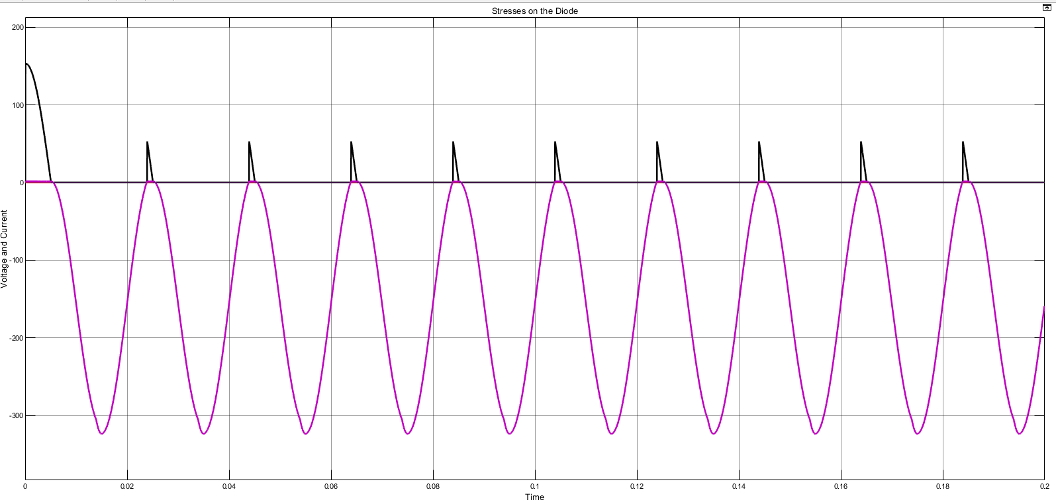

*Figure 12: Stresses on the diode*

**Q3)**

1. MEAN İS 522V

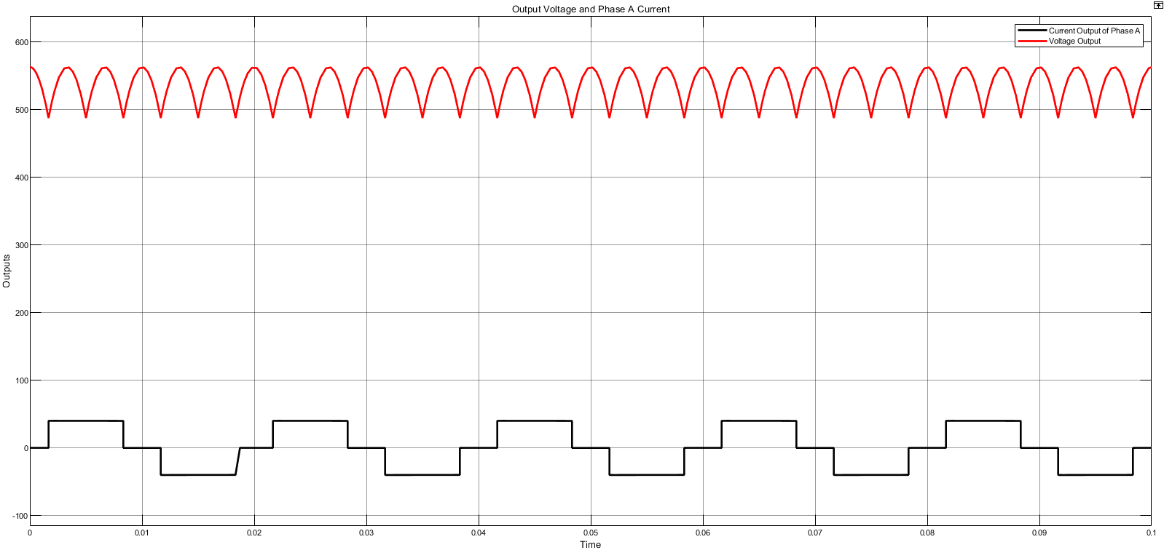

*Figure 13: Phase A current and output voltages*

1. Analiticly calculate
2. 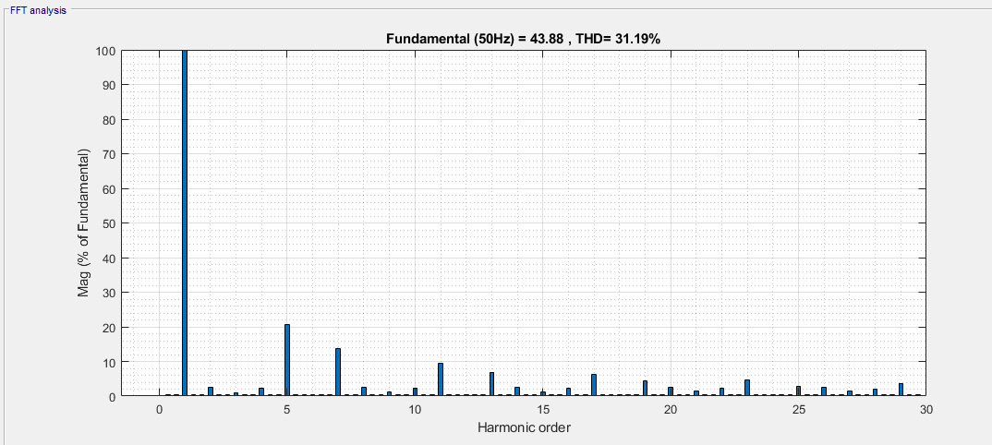

*Figure 14: Harmonic analysis for input current*

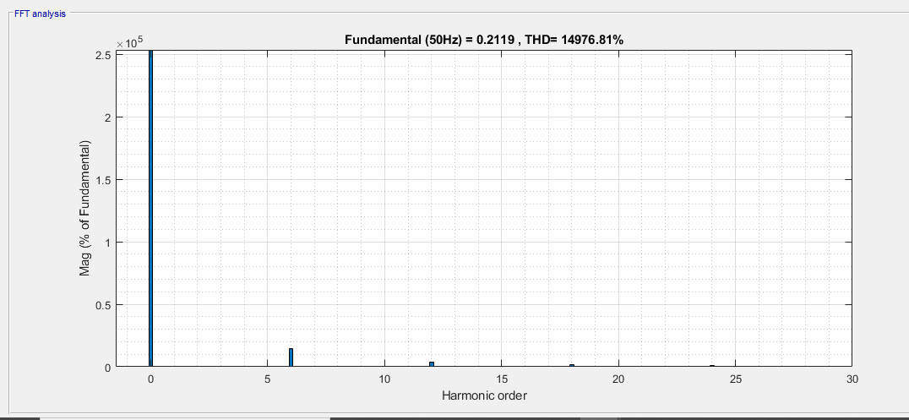

*Figure 15: Harmonic analysis for output voltages*

1. MEAN İS 509V

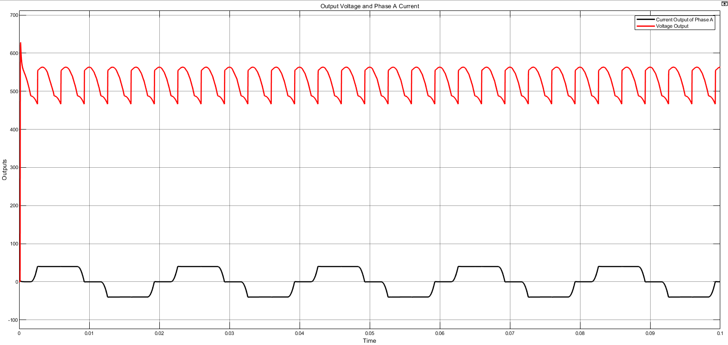

*Figure 16: Phase A current and output voltages for 1mH*

Obviously, we don’t have a signal rising up and down instantly now. Since an inductance is introduced, current cannot change rapidly. Rather, it follows a differentiable path whenever it tends to change. Since change in inductance current induces a voltage across the inductor, it affects phase voltage too.

1. **Repeat c**

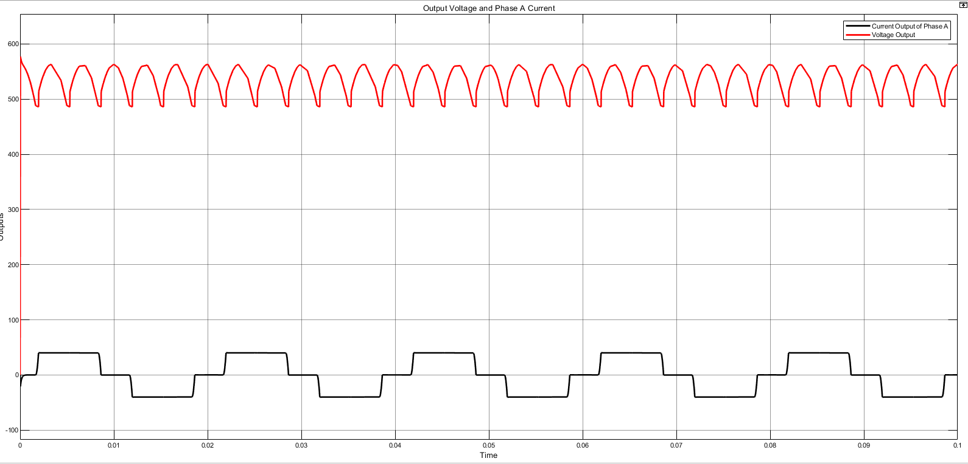

*Figure 17: Phase A current and output voltages for 0.1mH*

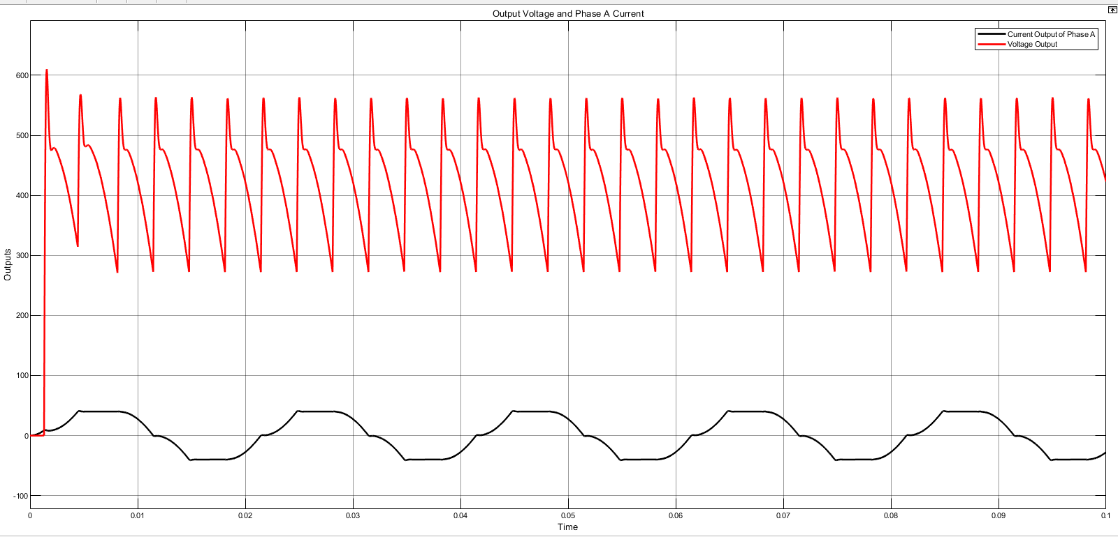

*Figure 18: Phase A current and output voltages for 10mH*